Chromatographic methods – worksheet
Case report:
In the evening hours, a 28-year-old man (175 cm, 72 kg) was brought to the Emergency Department. Findings: mydriasis, tremor, tachyarrhythmia, vomiting, and hyperthermia; suicidal ideation during transport to the hospital. Upon arrival at the Emergency Department, the patient lost consciousness and was transferred to the Intensive Care Unit. Urgent (STAT) samples were drawn for basic biochemistry, blood gas analysis, and toxicological screening.
Toxicological Screening (LC–MS Analysis)
The patient sample was analyzed using liquid chromatography coupled with mass spectrometry (LC–MS). The separation of compounds was performed on a Kinetex-C18 column (150 × 4.6 mm, 5 µm), which is a typical reversed-phase column. The stationary phase consists of C18 alkyl chains, while the mobile phase is a mixture of water and an organic solvent (acetonitrile). This system is suitable for non-polar to moderately polar compounds, which are retained in the stationary phase for different periods depending on their polarity.
Measurement conditions:
- Mobile phase A: water with 0.1% formic acid
- Mobile phase B: acetonitrile with 0.1% formic acid
- Elution gradient: 0–10 min – 20% B → 90% B
- Flow rate: 0.5 mL/min
- Column temperature: 40 °C

Task 1 (qualitative analysis of the sample):
Imagine you work at the Department of Clinical Toxicology of the University Hospital and need to provide a report to the attending physician. You have a pre-measured chromatogram of reference standards (Appendix 1A) and a chromatogram from the toxicology screening performed on the patient’s plasma (Appendix 1B). What was the cause of the patient’s severe condition—i.e., with what substance was he intoxicated?
Answer:

Task 2 (quantitative analysis of the sample):
Now that you know the cause of the intoxication, your task is to quantify the substance. Appendix 2 contains a table of measured peak areas (response) for standard substances at six different concentrations. It also lists the toxic and lethal concentration ranges for each substance. Using MS Excel, construct a six-point calibration curve for the noxa (toxic agent) identified in the patient’s plasma and determine its concentration. You will therefore also need the regression equation. Based on the toxic and lethal ranges (Appendix 3), assess the patient’s prognosis. Try to briefly formulate the finding as you would present it to the attending physician.
Answer:

Task 3 (Chromatographic Method – Overview):
Complete the following text and questions:
- Every chromatographic system contains two phases.
a) The mobile phase in this task is ____________ (polar / non-polar).
b) The stationary phase in the C18 column is ____________ (polar / non-polar).
- Which of the substances identified in Task 1 will be retained longer on the reversed phase? Try to explain why. (Consider their polarity.)

- Explain the term retention time.
What does it tell us about the properties of a given substance?

- Which parameter of the chromatogram (peak area, peak height, retention time)
a) is related to the amount of substance in the sample?
b) is used for its identification?

- What is the principle of separation in liquid chromatography?
(Briefly describe how the individual substances are separated.)

- Describe at least one type of interaction between the separated substances and the stationary phase.

- Give an example of two detectors used in combination with liquid chromatography. Specify what are the advantages of using a mass spectrometric detector.

- Complete the sentence:
“Reversed-phase chromatography is suitable for the separation of ____________ (polar / non-polar) compounds because ____________.”
- Suggest at least two other examples of how chromatographic methods are used in a clinical or toxicological laboratory.

Appendix 1A: Chromatogram of standards of selected addictive substances
Codeine
Morphine
Psilocybin
THC
Benzoylecgonine
Fentanyl
10
9
8
7
6
5
4
3
2
1
0
Time (min)
Response
Pseudoephedrine
Amphetamine
t_{r}=1.25 min
t_{r}=1.83 min
t_{r}=2.07 min
t_{r}=2.89 min
t_{r}=3.45 min
t_{r}=5.50 min
t_{r}=9.45 min
t_{r}=4.36 min
Substance
Appendix 1B: Chromatogram from toxicological screening of patient plasma
10
9
8
7
6
5
4
3
2
1
0
Time (min)
Response
t_{r}=2.91 min
t_{r}=9.47 min

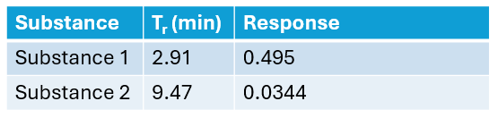

Appendix 2: Data for constructing the calibration curve (calibrator concentrations and their corresponding response)
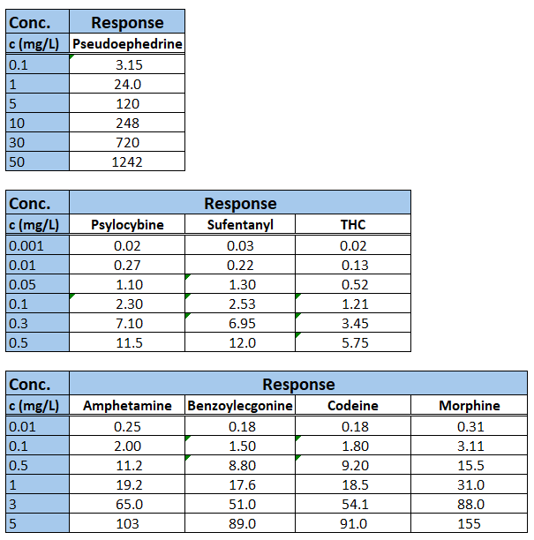
Appendix 3: Table of therapeutic/ “normal”, toxic and lethal plasma concentrations
Substance | Range of plasma concentrations (mg/L)
 | therap. /"normal" | toxic | lethal
Morphine | 0.01-0.1 | 0.1 | 0.1-4
Pseudoephedrine | 0.5-0.8 | N/A | 19-20
Codeine | 0.03-0.25 | 0.5-1 | 1.8
Psilocybine | 0.008 | 0.018 | N/A
Amphetamine | 0.02-0.1 | 0.2 | 0.5-1
Benzoylecgonin | 0.1 | N/A | 1
Sufentanyl | 0.0005-0.01 | N/A | 0.001-0.007
THC | 0.005-0.01 | N/A | N/A

